# Weight Loss in Response to Food Deprivation Predicts The Extent of Diet-Induced Obesity in C57BL/6J Mice

Matthew J. Peloquin1 and Dave Bridges1

1Department of Physiology, University of Tennessee Health Science Center and Department of Pediatrics, Children's Foundation Research Institute, Le Bonheur Children's Hospital and the University of Tennessee Health Science Center

Keywords: Obesity, Fasting Responses, Hormones, Predictive Measures

Fasting response as a predictor of weight gain

Corresponding Author: Dave Bridges, Department of Physiology, University of Tennessee Health Science Center, Nash Research Building, 894 Union Ave Room 517, Memphis, TN 38163, dbridge9@uthsc.edu

# Abstract

Inbred C57BL/6J mice have been used to study diet-induced obesity and the consequential physiological effects associated with it. Little is understood about predictive factors that predispose an animal to weight gain. To address this, mice were fed a high fat diet, control diet or normal chow diet. High fat diet fed mice exhibited a large amount of variation in body weights between the mice at the conclusion of the diet protocol. This variation is not present in obese leptin deficient mice, which have less variation in body weight. Several measurements including pre-diet serum hormone levels and pre-diet body weight were analyzed, but had no predictive value regarding weight gain. However, weight loss response due to food deprivation showed a strong positive correlation with high fat diet induced weight gain. These data suggest that adolescent fasting induced weight loss is a useful predictor of diet-induced weight gain.

# Introduction

Obesity is a major global health concern with an estimated 1.4 billion overweight and 500 million obese individuals worldwide [1]. Obesity has a complex etiology including both genetic and environmental inputs. It has been estimated that between 40-70% of obesity is heritable [2]. The non-heritable component of obesity and the factors that modulate it are harder to estimate independently due to variations in diet, exercise and other factors.

Identifying at risk populations of patients and determining how to prioritize limited health care spending is a major public health issue. However, outside of genetic tests for monogenic obesity disorders there are few good diagnostic criteria for early prevention of weight gain. Furthermore, the mechanisms that cause the variable susceptibility to diet-induced obesity are not well understood. Previous work has suggested a variety of factors are predictive of weight gain in human populations including birth weight [3, 4], leptin [5], adolescent weight [6] and binge eating [6, 7] but these are often difficult to separate from other genetic and socio-economic factors in human populations. Furthermore, the time at which these predictive factors should be assessed is not clear.

Mouse models of obesity have been important to our understanding of the molecular mechanisms underlying obesity by allowing investigators to control the genetics and environment of animals at a very high level. Inbred C57BL/6J mice are highly genetically similar and are maintained to reduce genetic drift [8, 9]. A previous study identified variable responses to weight gain in inbred C57BL/6J mice and suggested that this was established early in life, shortly after weaning [10]. To test the amount of variability in an inbred mouse strain we performed diet and genetic induced obesity studies on inbred mice in animal facilities at two sites. Animals were fed either an obesogenic high fat diet (HFD) or one of two control diets (CD or normal chow diet; NCD) and we examined both changes in their physiology and prospective determinants of weight gain.

# Materials and Methods

## Materials

Male C57BL/6J mice (stock number 000664) and ob/ob *(Lepob/ob*) mice (000632 for C57BL/6J and 0004824 for BTBR background) were ordered from The Jackson Laboratory (Bar Harbor, ME) and received at 8 weeks of age. NCD (8640 Teklad Rodent Diet) was provided by the University of Tennessee Health Science Center Laboratory Animal Care Unit (Memphis, TN) and the University of Michigan Animal Care Facility (Ann Arbor, MI). HFD (D12451) and CD (D12450H) were purchased from Research Diets (New Brunswick, NJ) and stored at 4°C until use. Blood glucose levels were measured using an OneTouch Ultra 2 Glucometer and OneTouch Ultra Test Strips. All animal procedures were approved by the Animal Care and Use Committee at UTHSC, and the University Committee on Care and Use of Animals UM.

## Animal Housing

Experimental mice from cohorts 1 and 2 were housed at the University of Michigan Animal Care Facility (Ann Arbor, MI). Experimental mice from cohorts 3 and 4 were housed at the University of Tennessee Health Science Center Laboratory Care Unit (Memphis, TN). Mice in diet groups Normal Chow and CD were housed 5 mice per cage, while mice in the HFD group were housed 4 to a cage. All mice were kept on a 12/12 light dark cycle for the duration of the study. Mice being fed Normal Chow and HFD were given 300g of food every 2 weeks, while mice fed CD received 400g. Cage-level food consumption and individual body weights were measured at every 2-week interval at approximately ZT11, at which point the appropriate food was replenished back to the original amount.

## Fasting Response and Tissue Collection

Prior to starting the experimental diets, mice were weighed and fasted for 16 hours from ZT11 to ZT4 in clean cages with unrestricted access to water. Following the fast, blood glucose levels and weight measurements were taken. Following the completion of the 12-week experimental diet treatment, the same procedure was repeated.

## Hormones and Glucose Measurements

Serum hormone levels were measured using a Bio-Plex Pro Mouse Diabetes Panel 8-Plex kit (#171-F7001M) on a Luminex 100/200 Plate reader with xPONENT software. Bio-Plex was conducted as described by the kit.

Blood glucose levels were taken from all experimental mice after 16 hours of fasting pre-diet and post-diet, while refed blood glucose levels were taken for approximately half of the mice. Blood was extracted from the retro orbital vein using a micro hematocrit capillary tube, then placed on ice for 20 minutes to clot, followed by a 20 minute spin at 2000g and storage of the serum at -80C. Glucose was measured from whole blood using an OneTouch Ultra 2 Glucometer.

## Statistics

All statistical analyses were performed using R version 3.0.2 [11]. Alterations in food intake were examined using mixed effects linear modeling using lme4 (version 1.0-6 [12]). To determine the effect of diet week, we generated a mixed linear model containing the diet type and week as the fixed effects and the cage as the random effect. We compared this to models without the week factor and performed a F-test comparing these models. Similarly, to test the effects of diet we compared to a model without the diet type term. To examine the effects of specific differences from HFD fed animals we performed a Dunnett’s test on the mixed effects models using the multcomp package (version 1.3-2 [13]).

To test for differences in the amount of variation between diets we performed Brown-Forsythe tests with the null hypothesis that the populations had equal variances using the lawstat package (version 2.4.1 [14, 15]). Correlations were tested by determining Pearson’s correlation coefficient and testing against the null hypothesis that r=0. For potential correlates of weight gain, p-values were adjusted for multiple observations by the method of Benjamini and Hochberg [16].

For examining effects of the three dietary treatments, we first performed an ANOVA, and if that was significant, a Tukey post-hoc test was used. To do pairwise tests, first the data was examined by a Shipiro-Wilk test to determine normality, then a Levene’s test for equal variance. Based on this either a Student’s T-Test was used or a Wilcoxon rank sum test was performed, as indicated in the figure legends. To determine how much of the variability we can account for with diet and fasting responses, we generated a linear model of our data accounting for the diet type and the Pre-Diet fasting response and determined the adjusted R2 of this model. All raw data and reproducible analysis code for this manuscript are available at https://github.com/BridgesLab/PredictorsDietInducedObesity.

# Results and Discussion

## Characterization of Effects of Diets on Weight Gain

**Table 1: Description of Normal Chow Diet, Control Diet and High Fat Diet used during the course of the study.** Carbohydrates are sub grouped into sucrose and starch.

|  |  |  |  |
| --- | --- | --- | --- |
| Food | Normal Chow | Control Diet | High Fat Diet |
| Fat (%) | 5 | 10 | 45 |
| Protein (%) | 22 | 20 | 20 |
| Sucrose (%) | 3.7 | 17 | 17 |
| Starch (%) | 32 | 44 | 7 |
| Calories per gram | 4.07 | 3.85 | 4.73 |
| Type | Chow | Synthetic | Synthetic |

To test the effects of HFD on weight gain in inbred mice, we placed independent cohorts of 10-week old C57BL/6J male mice on either a NCD, CD or HFD for 12 weeks (see Supplementary Figure 1A). Often, mice are raised on NCD, but due to the substantial differences in chemical make up of this diet and synthetic diets we also tested a control diet. The CD had less fat (10% to 40%) compared to the HFD and also had identical protein and sucrose content (Table 1). We examined the effects of weight gain over four separate cohorts of mice, and found that the HFD fed mice gained substantially more weight than the CD or NCD mice, but also that the CD mice gained substantially more weight than the chow mice (Supplementary Figure 1B). We found minimal variation across cohorts in their response to diets (Supplementary Figure 1C). HFD fed mice weighed significantly more at all time points during the 12-week diet treatment compared to the NCD fed mice in cohorts 3 and 4, as well as CD fed mice in cohorts 5 and 6 (Supplementary Figure 1B-C).

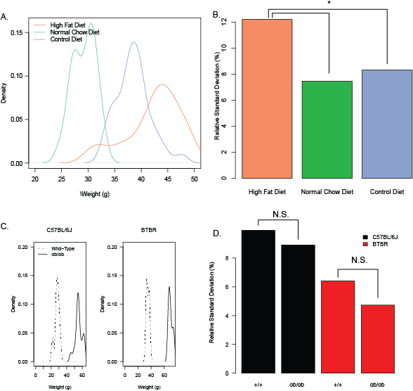

**Figure 1: High fat diet-fed mice show more variation in weight compared to control and normal chow diets, or *ob/ob* mice.** A) Density plot describing the post-diet body weight in HFD, CD and Normal Chow fed mice. HFD fed mice body weights were significantly more variable than CD and Normal Chow fed groups. B) Variation in post-diet body weight across all treatment groups at the conclusion of the 12-week diet treatment. C) Density plot describing the weights of *ob/ob* and wild type mice (+/+) on C57BL/6J and BTBR backgrounds. D) Variation in body weights between *ob/ob* and wild type mice on C57BL/6J and BTBR backgrounds. Asterisk indicates p < 0.05 by Browne-Forsythe test Following, N.S. indicates not significantly different (p>0.05).

To probe the effects of the diet on food intake, we measured the amount of food consumed by each cage of mice on a bi-weekly basis. We found that food intake on both a per gram basis (Supplementary Figure 1D, p=0.0033) and a caloric basis (Supplementary Figure 1E, p=0.0038) trended to decrease even as the mice gained weight. There was a significant effect of diet (p<0.005 for both caloric and absolute food intake by F-Test) on the amount of food intake. Specifically, we observed that the CD fed animals consumed 1.1 g/mouse/day or 2.44 kcal/mouse/day more food than HFD fed animals (p< 0.0005 for each comparison). The chow fed animals also ate more grams of food (0.48g/mouse/day p = 2.8 x 10-5), but approximately the same number of calories as the HFD fed animals (p=0.18). These data support the hypothesis that high fat content specifically causes weight gain; even when total calories consumed are reduced.

To test whether the synthetic CD generated similar metabolic changes as NCD to HFD comparisons, we examined serum hormone levels of key obesity related factors in both the fasted and refed conditions (Supplementary Figure 2A) and blood glucose levels (Supplementary Figure 2B). Significant differences of HFD were detected between several hormones (resistin, ghrelin and leptin) as well as fasting glucose levels between these diets. These are consistent with previous reports of HFD induced changes relative to chow diets [17, 18].

## Weight Variation Amongst Obese Mouse Models

At the end of the 12-week period, we observed that HFD fed mice had significantly more variation in their final body weight than either CD (p=0.018) or NC fed mice (p=0.0039, see Figures 1A and 1B). To test whether this increased variation is simply due to the increased body weight we examined the variation between genetically obese mice on either a BTBR or C57BL/6J genetic background. *ob/ob* mice are leptin deficient due to a single nucleotide polymorphism in the leptin gene. This results in mice which eat the same type of food (NCD), but substantially more of it, leading to obesity [19–22]. The effects of this mutation on body weight and fasting glucose in these strains are shown in Supplementary Figures 3A-B). Despite of substantial obesity and hyperglycemia, variance in body weights at 120 days did not differ between the *ob/ob* mice relative to the wild-type mice in either of the two different genetic backgrounds (p=0.214 for C57BL/6J and p=0.318 for BTBR, Figures 3B-C). In fact, in both these backgrounds, the obese mice exhibited less variability in body weight than their lean wild-type controls. These data support the hypothesis that HFD induced obesity results in substantially more variability in weight gain than *Lep* mutations. This also suggests that it is not the obesity *per se* that causes the increased variation in weights, but something more specific to diet-induced obesity.

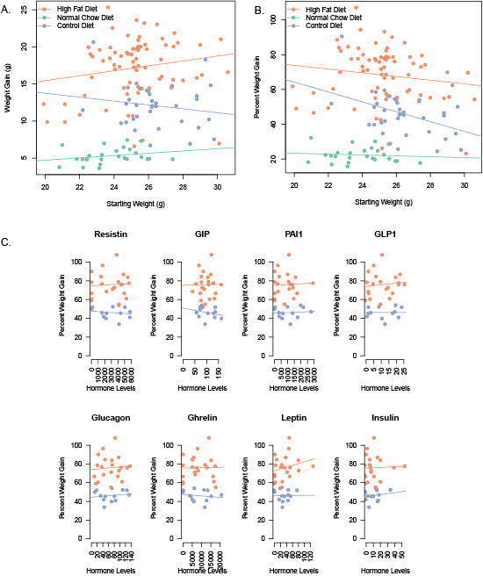

**Figure 2: Pre-diet weight and hormone levels have no predictive value for high fat diet-induced weight gain.** A) Pre-diet weight of mice compared to weight gain (A) or percent of weight gained (B) while on the diet. C) Fasted hormone levels in serum prior to diet compared to percent weight gain on the diets (also see Table 2).

## Predictors of Weight Gain

To understand the variance in body weight that occurs within an inbred mouse line, we tested several potential factors for their ability to predict weight gain. We first investigated if pre-diet body weight had any correlation with eventual weight gain (Figure 2A and B). We observed no correlation between initial pre-diet body weights and weight gain post-diet in both absolute weight gain (p=0.23, R2=0.06) and percent weight gain (p=0.65, R2=0.0092) for HFD fed animals.

We next examined serum collected from mice before they were placed on the diets, to test the hypothesis that pre-diet serum hormone levels are associated with weight gain in HFD fed mice. We observed no significant correlation between pre-diet hormone levels and weight gain in both HFD and CD fed mice (Figure 2C and Table 2). Collectively, these data suggest that pre-diet body weight and common metabolic hormone levels are not predictive of weight gain in male C57BL/6J mice.

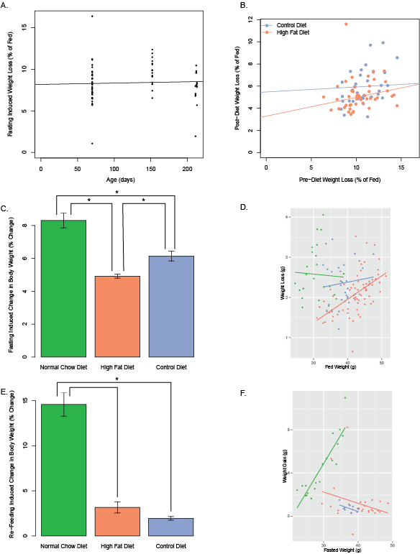

**Figure 3: Effects of Dietary Treatments on Fasting Responses.** A) Fasting induced weight loss unaffected by ageing within mice up to ~200 days. B) Pre-diet weight loss percent shows no significant correlation to post-diet percent of weight loss in HFD and CD fed mice. C) Change in percent of body weight due to fasting for 16 hours for each of the diets. D) Effects of body weight on percent weight loss for each group. E) Change in body weight percent after 6 hours of refeeding, following the 16 hour fast. F) Effects of body weight on percent weight re-gain for each group. Asterisk indicates a significant difference between groups by Tukey Test after a significant ANOVA result (p<0.001)

One hypothesis is that one dominant mouse may affect the weights of other mice

in its cage. To test this we looked at the mice which are the 5 heaviest from our

data, existing in 5 distinct cages. Those cages contained 20 mice in total. The other 15 mice in these cages (excluding the heavy ones) weighed on average slightly more than the average of all other mice analyzed. Since these mice did not weigh significantly lower (p=0.392), they do not support the hypothesis that one heavy, dominant mouse drives the weights of its cage-mates to be lower (Supplementary Figure 4). By the same token, the presence of a larger mouse does not make the other mice in that cage mice any heavier.

## Fasting Response Predicts Weight Gain

Another factor that we examined was the effect of food deprivation on body weight. To do this, we deprived mice of food for 16h both before the dietary intervention, and after it. Fasting responses were unchanged within male C57BL/6J mice over time at a population level (Figure 3A), but were do not correlate with pre-diet weight loss within mice (Figure 3B) in the same mouse. As shown in Figure 3C, fasting weight loss was significantly higher in NCD mice than in the HFD or CD mice (p<0.0001). CD-fed mice also had a more robust fasting response than HFD mice (p=0.00095).

We next tested whether the post-diet body weight could explain these differences in fasting and refeeding responses. Globally, there was no correlation between body weight and fasting response (p=0.881). When we separated the mice by dietary treatment we observed a significant positive correlation between body weight and absolute weight loss in the HFD treated mice only (R2 = 0.308, p=1.1 x 10-6, Figure 3D). If we examine percent weight loss rather than absolute weight loss, there is no correlation between weight loss and body weight in the HFD fed animals (p=0.425).

When the fasted mice were re-fed for 6 hours, NCD fed mice gained significantly more body weight than either HFD or CD fed mice (p<1 x 10-5, Figure 3E). In the case of NCD (R2=0.804, p=2.0 x 10-7) but not the two synthetic diets (HFD or CD), there was a strong positive correlation between body weight and their refeeding induced weight gain over those 6 hours (Figures 3F). These data suggest that responses to re-feeding are strongly altered by dietary type (synthetic versus chow) but independent of their body weights.

For leptin mutant *ob/ob* mice, we observed inconsistent results between strains. For C57BL/6J-*ob/ob* mice, we observed a significant increase in fasting induced weight loss relative to control mice, opposite to what we observed for diet-induced obesity mice (Supplementary Figure 5). However, for BTBR-*ob/ob* mice, we observed an increase in the percent weight loss. These data suggest that background differences play a role in fasting response in the absence of leptin.

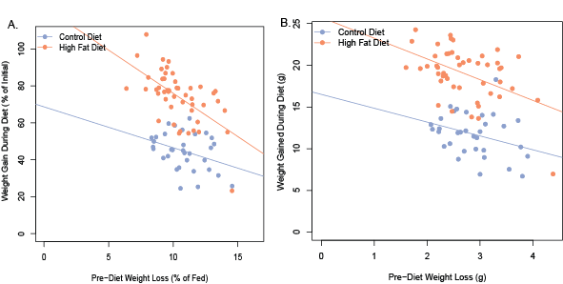

**Figure 4: Pre-diet fasting response negatively correlates with weight gain.** Correlation between mice in pre-diet fasting induced weight loss and diet-induced percent (A) or absolute (B) weight gain.

We then tested whether the pre-diet fasting response is predictive of eventual weight gain during the course of the diet for the two synthetic diets. Both HFD and CD fed mice showed a strong negative correlation between pre-diet fasting response and weight gain throughout the dietary treatment (Figure 4A and B). We examined the correlations between weight gain on HFD and pre-diet fasting response and found a significant negative effect (r=-0.479, R2 =0.230, p=0.00057). Similarly for CD fed mice the same pattern was present (r=-0.569, R2 =0.324, p=0.00044). In terms of percentage weight gain we also observed a significant correlation between this and fasting response for HFD (r=-0.602, R2 =0.362, p=6.06 x 10-6) and CD (r=-0.683, R2 =0.466, p=8.66 x 10-6).

Mice that resisted weight loss during the pre-diet 16 hour fast were far more susceptible to weight gain while on the experimental diet, both in terms of absolute and percent weight gain. Together, the pre-diet fasting responses combined with the dietary treatment were able to account for 67.8% of the variability in absolute weight gain and 68.8% of the percent weight gain.

# Conclusions

In this study we have described the physiological effects of dietary manipulation in a common inbred strain of laboratory mice. The aim of this study was to control the genetic background, environment and diet of these laboratory animals as closely as possible in order to assess the amount of variability that is not due to genetic differences.

**Table 2: Correlation between Pre-Diet Measurements and Percent Weight Gain on a Control or High Fat Diet.** P-values are adjusted for multiple comparisons by the method of Benjamini and Hochberg and presented as q-values. Measurements are ordered by predictive effect on HFD.

|  |  |  |  |  |
| --- | --- | --- | --- | --- |
| Pre-Diet Measurement | HFD R2 | HFD q-value | CD R2 | CD q-value |
| Fasting Response | 0.362 | 0.00061 | 0.466 | 0.00087 |
| Leptin | 0.061 | 0.94 | 0.000 | 0.99 |
| Pre-Diet Weight | 0.059 | 0.94 | 0.028 | 0.86 |
| GLP1 | 0.011 | 0.96 | 0.000 | 0.99 |
| Glucagon | 0.007 | 0.96 | 0.028 | 0.86 |
| Resistin | 0.004 | 0.96 | 0.026 | 0.86 |
| PAI1 | 0.002 | 0.96 | 0.008 | 0.96 |
| Insulin | 0.000 | 0.96 | 0.036 | 0.86 |
| GIP | 0.000 | 0.96 | 0.074 | 0.86 |
| Ghrelin | 0.000 | 0.96 | 0.029 | 0.86 |

We have observed substantial within-strain variability in the response to HFD and have explored the physiological basis for these differences by examining a variety of pre-diet biomarkers. Similar to our findings of increased variance of weight on HFD, the single nucleotide polymorphism located in the FTO gene led to not only weight gain, but also increased phenotypic variance [23]. We did not observe any data supporting the hypothesis that under this paradigm pre-diet body weight or hormone levels are predictive of weight gain, but we did observe a strong predictive effect of body weight responses to food deprivation. Based on these data, the predictive utility of fasting responses is nearly 5 fold greater than that of leptin levels, which had been previously reported to be of some use in predicting weight gain [24]. The small effect sizes of SNPs associated with obesity through GWAS has prevented their clinical utility for predicting future weight gain [25–27].

This study does not attempt to address the underlying fundamental mechanisms for these differences but suggests that there is a physiological state established by the time the dietary treatment begins that causes differential weight gain. One possibility is that alterations in their basal metabolic rate cause these differences, as has been proposed in pediatric human populations [28, 29]. The underlying molecular mechanism may yet be some level of *de novo* genetic variation in these mice, or epigenetic modifications that alter sensitivity to dietary factors. This study provides a phenotypic framework to test these molecular hypotheses.

Of note it is interesting that fasting responses themselves are not stable throughout life on a per mouse basis (see Figure 3B). This suggests that either the fasting response is not causative of weight gain directly, or is only causal during a younger age. These data are consistent with reports that among adult human populations, basal metabolic rate is not reduced in obese individuals [30, 31]. These data support a model where susceptibility to weight gain is at least in part caused by a non-genetic factor which is established early in life. This is consistent with previous studies on these mice which also proposed that susceptibility to weight gain is determined early in life [10]. Understanding the mechanistic basis for the relationship between fasting induced weight loss and eventual weight gain may be relevant to providing better individualized care of pediatric populations, since it may help predict susceptibility to weight gain in young children.

# Acknowledgements

The authors would like to thank the Cormier Lab (Department of Pediatrics, UTHSC) for assistance with and use of the Luminex system. We would also like to thank Drs. David Buchner (Case Western Reserve University), Irit Hochberg (RAMBAM Health Care Campus), Shannon M. Reilly (University of Michigan), and Joan Han (University of Tennessee Health Sciences Center) for helpful suggestions and members of the Bridges and Reiter laboratories for insightful discussions.

# Conflict of Interest Statement

The authors declare that there is no conflict of interests regarding the publication of this paper.

# References

1. World Health Organization (2013). Obesity and Overweight. Available at: http://www.who.int/mediacentre/factsheets/fs311/en/.

2. El-Sayed Moustafa, J. S., and Froguel, P. (2013). From obesity genetics to the future of personalized obesity therapy. Nat. Rev. Endocrinol. *9*, 402–13.

3. Yu, Z. B., Han, S. P., Zhu, G. Z., Zhu, C., Wang, X. J., Cao, X. G., and Guo, X. R. (2011). Birth weight and subsequent risk of obesity: a systematic review and meta-analysis. Obes. Rev. *12*, 525–42.

4. Cnattingius, S., Villamor, E., Lagerros, Y. T., Wikström, a-K., and Granath, F. (2012). High birth weight and obesity--a vicious circle across generations. Int. J. Obes. (Lond). *36*, 1320–4.

5. Allard, C., Doyon, M., Brown, C., Carpentier, A. C., Langlois, M.-F., and Hivert, M.-F. (2013). Lower leptin levels are associated with higher risk of weight gain over 2 years in healthy young adults. Appl. Physiol. Nutr. Metab. *38*, 280–5.

6. Tanofsky-Kraff, M., Cohen, M. L., Yanovski, S. Z., Cox, C., Theim, K. R., Keil, M., Reynolds, J. C., and Yanovski, J. a (2006). A prospective study of psychological predictors of body fat gain among children at high risk for adult obesity. Pediatrics *117*, 1203–9.

7. Bardone, A. M., Moffitt, T. E., Caspi, A., Dickson, N., Stanton, W. R., and Silva, P. A. (1998). Adult physical health outcomes of adolescent girls with conduct disorder, depression, and anxiety. J. Am. Acad. Child Adolesc. Psychiatry *37*, 594–601.

8. Taft, R. A., Davisson, M., and Wiles, M. V (2006). Know thy mouse. Trends Genet. *22*, 649–53.

9. Jackson Laboratories (2014). Patented Genetic Stability Program. Available at: http://jaxmice.jax.org/genetichealth/stability.html.

10. Koza, R. A., Nikonova, L., Hogan, J., Rim, J., Mendoza, T., Faulk, C., Skaf, J., and Kozak, L. P. (2006). Changes in gene expression foreshadow diet-induced obesity in genetically identical mice. PLoS Genet. *2*, e81.

11. R Development Core Team, and R Core Team (2011). R: A language and environment for statistical computing.

12. Bates, D., Maechler, M., Bolker, B., and Walker, S. (2014). lme4: Linear mixed-effects models using Eigen and S4.

13. Hothorn, T., Bretz, F., and Westfall, P. (2008). Simultaneous Inference in General Parametric Models. Biometrical J. *50*, 346–363.

14. Gastwirth, J. L., Gel, Y. R., Hui, W. L. W., Lyubchich, V., Miao, W., and Noguchi, K. (2013). lawstat: An R package for biostatistics, public policy, and law.

15. Brown, M. B., and Forsythe, A. B. (1974). Robust Tests for the Equality of Variances. J. Am. Stat. Assoc. *69*, 364–367.

16. Benjamini, Y., and Hochberg, Y. (1995). Controlling the False Discovery Rate: A Practical and Powerful Approach to Multiple Testing. J. R. Stat. Soc. Ser. B *57*, 289–300.

17. Steppan, C. M., Bailey, S. T., Bhat, S., Brown, E. J., Banerjee, R. R., Wright, C. M., Patel, H. R., Ahima, R. S., and Lazar, M. a (2001). The hormone resistin links obesity to diabetes. Nature *409*, 307–12.

18. Frederich, R. C., Hamann, A., Anderson, S., Löllmann, B., Lowell, B. B., and Flier, J. S. (1995). Leptin levels reflect body lipid content in mice: evidence for diet-induced resistance to leptin action. Nat. Med. *1*, 1311–4.

19. Ingalls, A. M., Dickie, M. M., and Snell, G. D. (1950). Obese, a new mutation in the house mouse. J. Hered. *41*, 317–8.

20. Mistry, A. M., Swick, A. G., and Romsos, D. R. (1997). Leptin rapidly lowers food intake and elevates metabolic rates in lean and ob/ob mice. J. Nutr. *127*, 2065–72.

21. Halaas, J., Gajiwala, K., Maffei, M., Cohen, S., Chait, B., Rabinowitz, D., Lallone, R., Burley, S., and Friedman, J. (1995). Weight-reducing effects of the plasma protein encoded by the obese gene. Science (80-. ). *269*, 543–546.

22. Zhang, Y., Proenca, R., Maffei, M., Barone, M., Leopold, L., and Friedman, J. M. (1994). Positional cloning of the mouse obese gene and its human homologue. Nature *372*, 425–32.

23. Yang, J., Loos, R. J. F., Powell, J. E., Medland, S. E., Speliotes, E. K., Chasman, D. I., Rose, L. M., Thorleifsson, G., Steinthorsdottir, V., Mägi, R., et al. (2012). FTO genotype is associated with phenotypic variability of body mass index. Nature *490*, 267–72.

24. Ravussin, E., Pratley, R. E., Maffei, M., Wang, H., Friedman, J. M., Bennett, P. H., and Bogardus, C. (1997). Relatively low plasma leptin concentrations precede weight gain in Pima Indians. Nat. Med. *3*, 238–40.

25. Speliotes, E. K., Willer, C. J., Berndt, S. I., Monda, K. L., Thorleifsson, G., Jackson, A. U., Allen, H. L., Lindgren, C. M., Luan, J., Mägi, R., et al. (2010). Association analyses of 249,796 individuals reveal 18 new loci associated with body mass index. Nat. Genet. *42*, 937–948.

26. Bogardus, C. (2009). Missing heritability and GWAS utility. Obesity (Silver Spring). *17*, 209–10.

27. Loos, R. J. F. (2012). Genetic determinants of common obesity and their value in prediction. Best Pract. Res. Clin. Endocrinol. Metab. *26*, 211–26.

28. Griffiths, M., Payne, P. ., Rivers, J. P. ., Cox, M., and Stunkard, A. . (1990). Metabolic rate and physical development in children at risk of obesity. Lancet *336*, 76–78.

29. Roberts, S. B., Savage, J., Coward, W. A., Chew, B., and Lucas, A. (1988). Energy expenditure and intake in infants born to lean and overweight mothers. N. Engl. J. Med. *318*, 461–6.

30. Leibel, R. L., Rosenbaum, M., and Hirsch, J. (1995). Changes in energy expenditure resulting from altered body weight. N. Engl. J. Med. *332*, 621–8.

31. Ravussin, E., Lillioja, S., Anderson, T. E., Christin, L., and Bogardus, C. (1986). Determinants of 24-hour energy expenditure in man. Methods and results using a respiratory chamber. J. Clin. Invest. *78*, 1568–78.